**Task 1**

1. Git init – used for initialise the Git

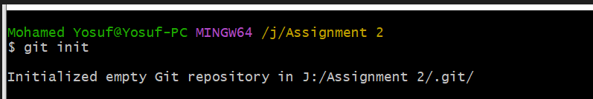

1. Git Status – to Know the status of Git

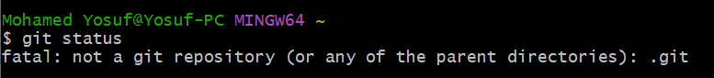

1. Git add – used for add the items in Git



1. Got commit - Replace the last commit with the staged changes and last commit

Combined. Use with nothing staged to edit the last commit’s message.

1. Git log – used for check the history

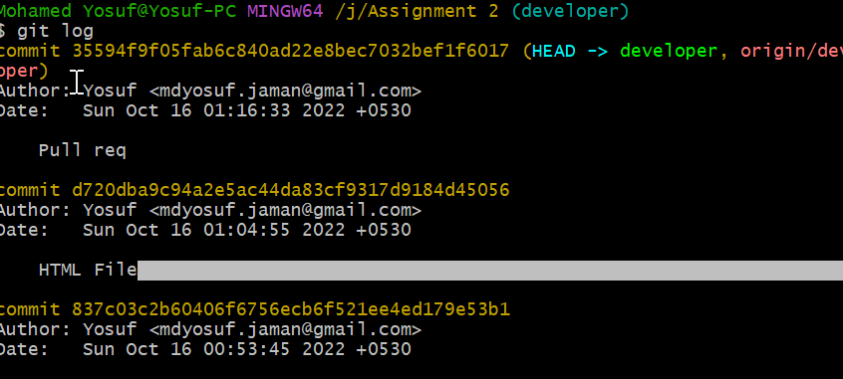

1. Git branch – used for find out the branch

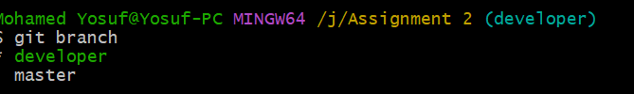

1. Git Fetch – used for find out the fetch and push

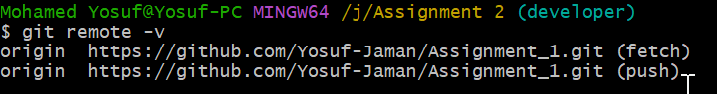

1. Git add origin path – to add a path



1. Git Switch – used for switch from one branch to another branch.

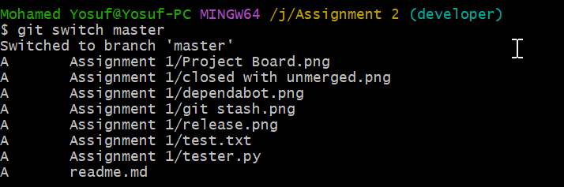

1. Git checkout (branch name)- other way to switch to other branch

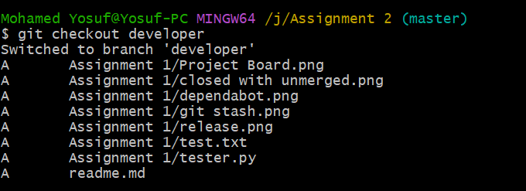

1. Git user.name – to find out the user name



1. Git user.mail – to find out the user email



1. Git merge dev1 – used for merge branch

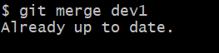

1. Git push

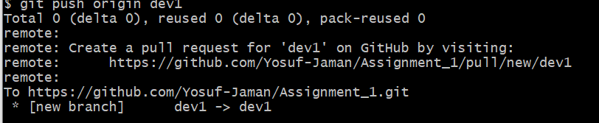

1. Git Tag- to find out the version

